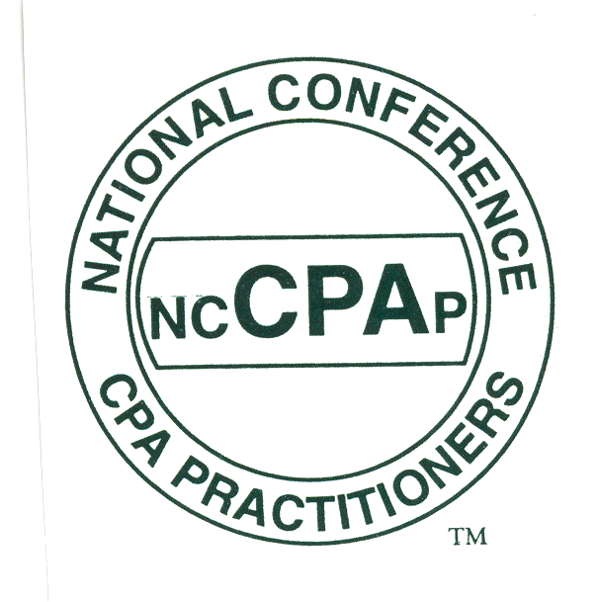
FOR IMMEDIATE RELEASE

Contact:
Shari Goldstein 631-595-7150 shari@goldsteinPR.com
Holly Coscetta 516-333-8282 execdir@nccpap.org

NATIONAL CONFERENCE OF CPA PRACTITIONERS (NCCPAP):

EQUAL RIGHTS FOR RETIREMENT ACCOUNTS

MINEOLA, NY – April 15 is more than just the deadline date for filing tax returns. It’s also the last day to make IRA, SEP, Keogh and all of other retirement plan contributions for 2005. You would think bargain savvy Americans would be lining up to take advantage of these many government-approved savings plans that creates a dollar-for-dollar tax deductions that grow over time while saving money for retirement.
Think again, says Neil H. Fishman, CPA, CFE, FCPA, CAMS, Vice-Chair, Tax Committee of the National Conference of CPA Practitioners (NCCPAP), a national accounting group. Most Americans are not saving for retirement, they are not maximizing the potential of retirement accounts and they don’t see this as a problem. The reasons for this may be complicated, but the answers are surprisingly simple.
The personal savings rate for Americans has gone into negative territory for the first time since 1933. Why are we refusing to save for our retirement? Many Americans have been lulled into a false sense of security, thinking their retirement will be easily funded with money invested through their workplace plan, most commonly the 401(k), and the value of their residence.
Let’s dispense with the value of the house retirement plan. A house may be sold at a high price, but one must live somewhere, so another house will need to be purchased – and it will be probably be bought for a proportionately high price. Relying on the sale of the family home to fund a retirement is not a plan.
More importantly, the small amount that people put into retirement plans through work is not going to yield what will be needed to maintain their current lifestyles. IRAs, 401(k)s and the like were originally created to encourage taxpayers to save for retirement with tax-deductible contributions. They are in effect a forced savings plan, put into place usually through payroll deductions, with tax deductions and a better quality of retirement life as the major incentives for saving.
But not all retirement plans are created equal. There are different limitations on what taxpayers are allowed to save, depending on the type of plan offered through work, or whether or not their spouse is participating in a plan or whether or not the taxpayer is self-employed. The dramatic difference in the size of allowable contributions can range from $4,000 for an IRA to $15,000 for a 401(k), while other plans allow even larger amounts to be contributed.
Currently there are so many phase-outs regarding marital status, employment status, status of spouses, etc., that the restrictions and limitations to these retirement accounts have become counterproductive. One person might be ready, willing and able to save $10,000 in an IRA – only to find that their contribution must be cut in half. The rules have become so complex that most Americans, even many employee benefits administrators, have a hard time navigating the choppy complex waters of retirement account rules.
NCCPAP recommends that with the exception of the Roth IRA, contributions to retirement plans should have no restrictions or at the very least, a much higher ceiling on allowed contributions. Regardless of the type of plan, all taxpayers should be encouraged to save as much as possible for their future. NCCPAP President Dennis Scott recommends that taxpayers and employers consult with their local practicing CPA to help sort through the myriad of plans to help find the one most suitable for their needs.
“If the only way that people are going to save is through these retirement plans, then contribution levels must be increased so that people can save as much as possible and at the same time, enjoy the benefits of lowering their tax liability,” says Dennis Scott, CPA, president of the National Conference of CPA Practitioners (NCCPAP) and a partner with the Oneonta NY based accounting firm of Gruver, Zweifel & Scott, LLP, CPAs.
NCCPAP has been working to educate law and policy makers about the disparity between retirement plans for many years. Members of NCCPAP have testified at Congressional hearings and consulted with the Internal Revenue Service. NCCPA has taken the position that people, regardless of their employment or marital status, should be allowed to contribute equally to any type of retirement plan, and that the maximum amount should be at a level much higher than currently allowed.
With concern growing each year over the solvency of Social Security, with current administration wanting to make the funding of retirement a personal issue, people at every income level must be encouraged to put away more for the future. At this time, it appears that the only way that people will save for the future is if they are encouraged to, or forced to. Increasing retirement plan contributions will do both.

The National Conference of CPA Practitioners (NCCPAP) is an association of member firms in public practice owned by CPA's and is committed to quality, integrity, and public responsibility for the public accountancy profession. Founded in 1979 to provide representation on a national level for smaller CPA firms and sole practitioners, NCCPAP members work actively with Congress, the IRS, state legislatures and taxing authorities in developing and refining tax policy and legislation. NCCPAP chapters are located in New Jersey and in New York in Nassau/Suffolk, Eastern Long Island, New York City, and Westchester/Rockland counties and Texas, and ad hoc members are located throughout the United States. For additional information, visit www.nccpap.org

# # #

022706

